The use of light as a means of communication is not a new idea; many civilisations used sunlight reflected off mirrors to send messages, and communication between warships at sea was achieved using Aldis lamps. Unfortunately, these early systems operated at very low data-rates, and failed to exploit the very large bandwidth of optical communications links.

Radio Light x-rays Gamma rays

10⁸ 10⁹ 10¹⁰ 10¹¹ 10¹² 10¹³ 10¹⁴ 10¹⁵ 10¹⁶ 10¹⁷ 10¹⁸ 10¹⁹ 10²⁰

Frequency (Hz)

10³ 10² 10 1 10⁻¹ 10⁻² Wavelength
(μm)

Infra-red Ultra-violet

Visible

The electromagnetic spectrum shown above reveals the facts about the extent of visible light ( 0.4 to 0.7μm), which converts to a bandwidth of 320 THz (1 THz = 10¹² Hz). If 1 percent of this capability were available it would allow for 80 billion, 4 Khz Channels! (If we could transmit the channels by radio, they would occupy the whole of the electromagnetic spectrum spanning from D.C. right up to far infrared. Incandescent (luminous) white light sources were used in early optical systems; a hand-operated shutter was used to interrupt its output. There was a major disadvantage in transmission speed; a white light source emits all known visible and invisible wavelengths at the same time. If we compare this phenomenon with the radio systems, this is the equivalent of a radio transmitter broadcasting a single programme over the whole of the radio spectrum – very inefficient! With this parallel in mind, an optical equivalent of an oscillator was needed before development of the light-wave communicator could further in development.
A breakthrough occurred in the 1960’s, T.H. Maimon invented the first ruby laser, working at the Hughes laboratories, USA. For the first time in history, an intensive, one wavelength coherent light source was made available. It was this direct development that started a race into the development in optical communications the world over.
The very early experiments were carried out with line-of-sight links; it was however later discovered that particular wavelengths were required in sending light efficiently. Light wave propagation could be interfered with easily by too many phenomenons in the atmosphere i.e. cloud, fog, rain and even flocks of birds. Hollow metallic materials were considered for waveguides, but because of their impracticality they were ruled out. By the year 1963, several hundred-glass fibres were already being used on small-scale production illuminations. However, these early models had very high attenuation’s (i.e. weakness in it’s structure) of around 1000+ dB/km and so their use for optical communications after all were not considered also.
It was in 1966 that C.K. Kao and G.A. Hockman (working at the Standard Telecommunications laboratories, UK) presumed the use of glass fibres as optical communications waveguides. Because of the glasses high attenuation, the idea was initially treated with some scepticism, in order to compete with existing co-axial cable transmission lines, to make the optical fibre a viable source the 20-dB/km-glass fibre attenuation had to be reduced. In 1970 after Kao and Hockman studied the loss mechanism, a fibre with the suitable fibre attenuation was created at Corning glass works in the USA. This find led to the first laboratory demonstration of optical communication with glass fibre in the early 1970’s.

COMPARISON OF WESTERN ELECTRIC COPPER WIRE CABLES WITH LIGHT GUIDE CABLE

FT3144 Fibres Cross section of typical cable
46,368*2-way conduit showing space saved
Voice circuits cable using light guided cable

EQUALS

OR OR OR

T1 900 pairs T1 1800 pairs T1C 1800 pairs T4M
10,300* 2-way 20,736* 2-way 41,472* 2-way 40,320* 2-way
Voice circuit/cable voice circuit/cable voice circuit/c voice circuit/c

While work progressed on reducing fibre attenuation, laser development continued with pace. With the advent of the semi-conductor laser, in 1962 meant that a fast light source was available. The material used was gallium arsenide, GaAs, which emits the light at a wavelength of 870 nm. With the discovery of the 850-nm window, doping the GaAs with aluminuim, Al, reduced the wavelength of the emission. Later modifications included different laser structures to increases device efficiency and lifetime. Various materials were also investigated, to produce devices for operation at 1.3 and 1.55μm. Unfortunately lasers are very expensive and so low-cost light emitting diodes, LED’s, have also being developed. Semiconductors have been developed and are now available which emit any one of a number of wavelengths, with the routine of many Gbit/s being routinely achieved in the laboratories.
At the receiver, a photodetector converts the optical signal back into an electrical one. The early optical communication links used avalanche photodiodes, APDs, which exhibit current multiplication, which means that single electron hole pair produced by the detection of a photon of light generates more electron hole pairs, so amplifying the signal. In 1973, S.D. Personick (working at the bell laboratories in the USA) analysed the performance of an optical PCM receiver. This theoretically showed that the study of an APD feeding an high imput impedance preamplifier, employing an FET input stage, would result in the best receiver sensitivity. Unfortunately, the early APDs required high bias voltages, typically 200-400V, and this made them unattractive for use in terminal equipment.
It was in 1978 that D.R. Smith, R.C. Hooper and I. Garrett (all working at British Telecom research Laboratories, Martlesham Heath, UK) published a comparison between the APD and a PIN photodiode followed by a low-capacitance, microwave FET input preamplifier (the so-called PINFET receiver). They showed that PINFET receivers using a hybrid of the thick film construction technique could achieve the sensitivity of that comparable to the APD receiver. They also indicated that the PIN receivers for the 1.3 and 1.55 μm transmission windows could not out perform an equivalent APD receiver. So the use of PINFET receivers operating in the long wavelength transmission windows meant that a signal could be sent over very long distances – ideal for trunk route telephone links.
The work on long – haul routes aided the development of short – haul industrial links. From an industrial point of view, the major advantage of an optical link is that it is immune to electromagnetic interference. Hence optical fibre links can operate in electrically noisy environments, which would disrupt a hard – wire system. For short - haul applications, expensive low – loss glass fibres, lasers and very sensitive receivers are not required. Instead, all plastic fibres, LEDs and low – cost bipolar preamplifiers are often used. These components are readily available on the commercial market, and are usually supplied with connectors attached for ease of use.

The Optical Communications Link

An optical communications link is similar to other links in that at consists of a transmitter, a communication channel and a receiver In the diagram below a closer examination shows that the communication channel is an optical fibre.

Drive circuit Fibre Detector

Source Post
Detection Circuit

Preamplifier

In order for the fibre to guide light, it must consist of a material whose core has a refractive index greater than the surrounding medium – known as cladding. Depending on the design of the fibre, total internal reflection or refraction constrains the light to the core.

Cladding Jacket

Core

In optical links, the transmitter is a light source whose output acts as the carrier wave. Although frequency division multiplexing, fdm, techniques are also used in analogue broadcast systems, most optical communications links use digital time division multiplexing, tdm, techniques. The easiest ways to modulate a carrier wave with a digital signal is to turn it on and off, so called on and off keying, or amplitude shift keying, ASK. In optical systems this is often achieved by varying the source drive current directly, so causing a proportional change in optical power. The most common light sources in use at present are semiconductor laser diodes and LEDs.
At the receiving end of an optical link, a PIN photodiode or an APD, converts the modulated light back into an electrical signal. The photodiode current is directly proportional to the incident optical power. (If we draw a parallel with radio receivers, this detection process is similar to the very simple direct detection radio receivers.) Depending on the wavelength of operation, photodiodes can be made out of silicon, germanium or an alloy of inidium, gallium and arsenic.
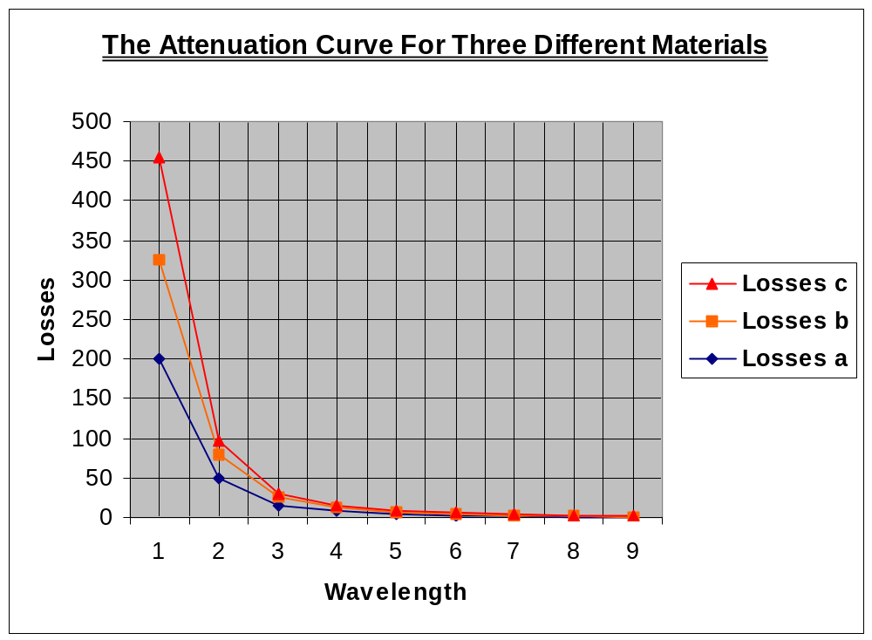
Ultimately, for a limited transmitter power and wide bandwidth channel, it is the receiver noise that limits the maximum transmission distance, and hence repeater spacing. The receiver noise depends on bandwidth – a low bandwidth receiver results in a low noise. However, if the bandwidth is too low, the received channel will be distorted. Therefore receiver design is often a compromise between minimising the noise, while maintaining an acceptable degree of signal corruption.
Low-noise preamplifiers are used to boost the small amplitude signal appearing at the output of the photodetector. At present there are two main types: the high imput impedance FET design, PINFET, and the transimpedance feedback design. Of the two designs, the PINFET preamplifier is currently the most sensitive design available and, as such, finds applications in long haul telecommunications routes. Transimpedance designs are usually fabricated with bipolar transistors and, although they are noisier than PINFET designs they are usually cheaper to design and produce, with ease of finding applications in short-to-medium haul routes. Bipolar transistors are generally more reliable than FETs, and so bipolar transimpedance preamplifiers are also used as repeaters in submarine optical links.

Optical Fibre

In most optical communication links, it is optical fibre that provides the transmission channel. The fibre consists of a solid cylinder of transparent material, the core, surrounded by a cladding of a similar material. Light waves propagate down the core in a series of plane wavefronts, or modes; the simple light ray path used in elementary optics is an example of a mode. For this propagation to occur the refractive index of the core must be larger than that of the cladding and there are two basic structures which have this property; step index and graded index fibres. Of the step index types, there are multimode, MM, fibres (which allow a great many modes to propagate), and single mode, SM, fibres (which allow only one mode to propagate). Although graded-index fibres are normally MM, some Sm fibres are available.
The three fibre types, together with their respective refractive index profiles, are shown in the diagram below. (In the diagram below n represents the refractive index of the material.) The crosshatched area represents the cladding, the diameter of which range from 125 μm to a maximum of 1 mm. The core diameter can range from 8 μm, for SM fibres, up to typically 50 μm for large core MM fibres.

N n n
50 8 50

125 125 125

Distance Distance Distance

(a) (b) (c)

Typical refractive index profiles of (a) step-index multimode, (b) step-index single mode, and (c) graded-index multimode fibres. (All dimensions are in μm.)

Most of the optical fibres in today’s usage are made from either silica glass (SiO₂) or plastic. The change in refractive index, between the core and the cladding, is achieved by the addition of certain dopants to the glass; all-plastic fibres use different plastics for the core and cladding. All-glass, SM fibres exhibit very low losses and high bandwidths, which make them ideal for use in long-haul telecommunications routes. Unfortunately such fibres are expensive to produce so are seldom found in short-haul (less than 500m length) industrial links.
Large core fibres for use in medical and industrial applications are generally made of plastic, making them more robust than all-glass types and overall are much cheaper to manufacture. However, the very high attenuation and low bandwidths of these fibres tend to limit their use in communications links. Medium-haul routes, between 500 m and 1km lengths, generally use plastic cladding/glass core fibre, otherwise known as plastic clad silica, or PCS. All-plastic ans PCS fibres are almost exclusively step-index, multi-mode types.
The attenuation and bandwidth of an optical fibre will determine the maximum distance the signal can be sent. Attenuation is usually expressed in dB/km, while bandwidth is usually quoted in terms of bandwidth length product, which have the units of GHzkm, or Mhzkm. Attenuation depends on impurities in the core, and so the core fibre must be made from very pure materials. The bandwidth also depends on the core purity, the number of propagation modes usually limits the bandwidth. This explains why single-mode fibres have a very large bandwidth.

Current Systems and Future Trends

In the previous pages I concentrated on the design and performance of individual components for use in optical links. What isn’t examined however is the overall design of the practical links, and it is just this which initially is a concern.
When designing an optical link, systems designers commonly use a power budget table which details the power losses encountered from source to receiver. This table helps the designers to implement the systems margins to account for ageing effects in links. Using the power budget we can contrast to general cases: a low speed data link using PCS fibre and LEDs, and a high speed telecommunication link using all glass fibres and lasers. Then this will enable us to examine the design of two current optical communications links.
Looking further ahead, in the following paragraphs we will examine the advanced components and systems that are being developed in the laboratory, assessing their impact on optical communications.

System Design (Assessing the Power Budget Table)

 |  | Short-haul link (10 Mbit/s) |  | Long-haul link (1.2 Gbit/s)
Launch power | LED | -15 dBm | Laser | -3 dBm
Receiver sensitivity |  | -45 dBm |  | -34 dBm
Allowable loss |  | 30 dB |  | 31 dB
Source coupling loss |  | 3 dB |  | 2 dB
Fibre loss | (6 dB/km) | 3 dB |  | 0.2 dB/km
Joint loss | (2 dB/km) | 8 dB |  | 0.2 dB/splice
Detector coupling loss |  | 3 dB |  | 2 dB
Headroom |  | 5 dB |  | 8 dB
Operating margin |  | 8 dB |  | 7 dB

Link power budgets for a short-haul, low-data-rate link, and a long haul, high-data-rate link.

The table above shows the power budget for the two links. Because the short-haul link operates at a low data rate, we can specify it must use a PCS fibre and an LED source. It is also assumable that the link is made up of five, 100m lengths of fibre, requiring four pairs of connectors. For the high-speed link, we will take laser diode sources and 1km lengths of dispersion shifted, single mode all-glass fibre, connected together with fusion splices.
The last two parameters in the table, headroom and operating margin represent excess power in the link. The headroom parameter is included to allow for the insertion of extra connectors, or splices, should a break in the fibre occur, as well as accounting for any power changes due to the effect of age. The headroom for the laser link is larger than for the LED link because laser output falls with age, whereas that of an LED remains relatively constant. The operating margin may be taken up by manufacturing varying the source power, receiver sensitivity and fibre loss. It will also allow for the addition of extra components such as power splitters and couplers.

Current Systems

In this section of the essay will briefly examine the first optical transatlantic cable, TAT8, and to contrast, a computer communications operating link at the Joint European Torus at Culham, UK. Although the technology used is very different in both cases, reliability is the important factor.
TAT8 is the first optical transatlantic communications link. The cable has been laid in three sections, with a different manufacturer taking responsibility for each. The first section has been designed by the American telephone and Telegraph Co., AT&T, and is a 5600 km length from the USA to a branching point on the continental shelf, to the west of Europe. At this point the cable splits to France and the UK. The French company Submarcom designed the 300 km length link to France, while the British company Standard Telephones and Cables, STC, were responsible for the 500 km link to the UK.

TAT8 Optical communications link

TAT8 cables comprised of six individual fibres; two active pairs carry two-way traffic at a data rate of 295.6 Mbit/s on each fibre. As well as parity bits, some of the transmitted bits are used for system management’s purposes and so the total capacity is 7560 voice channels. This should be compared with the 4246 channels available on the TAT7 co-axial cable link. Control circuitry enables a spare cable to be switched in if one of the active cables fails.
By way of contrast, engineers at the Joint European Torus, JET, fusion reaction experiment use of an optical link to transmit computer data around the site. Although the environment is electronically noisy, the main reason for the use of an optical link is electrical isolation. This is because earth loop faults could cause a high difference in the earth potential between the ends of the data link, and this would prove fatal to a hard-wired link.

Future trends

Fluoride based optical fibres

One of the latest advances in optical fibres is the development of single mode optical fibres, which exhibit very low-loss in the mid infra-red region, above 2 μm. Rayleigh scattering reduces as wavelength to the fourth power, and so very-low transmissions require operations at long wavelengths. However, in silica fibres, the absorption increases rapidly for wavelengths above the 1.55 μm window, and so very low-loss fibres have to be made from a different material.
The most promising glasses for low-loss fibres are those based on fluoride compounds. Of these zirconium fluoride, ZrF₄, and beryllium fluoride, BeF₂, glasses have projected attenuations at 2.5 μm of 0.02 dB/km and 0.005 dB/km respectively. Unfortunately BeF₂ is highly toxic, and so most of the work has been done with zirconium fluoride in mind. Investigations show that the major loss mechanism is scattering for imperfections formed in the fibre during manufacture. So, with a more refined process, attenuations close to the Rayleigh scattering limit should be achievable.
The move to higher wavelengths is likely to see a new generation of lasers and detectors. The most promising semiconductor laser source is a double hetrojunction SLD, based on InAsSbP matched to an InAs substrate. InGaAs photodiodes can operate at long wavelengths, but lead sulphide, Pbs, detectors also show promise.

